 | RE Year Six  Ascension and Pentecost  What is the importance of Ascension and Pentecost to Christians?
Key vocabulary | Explanation/ definition | Key Knowledge
Ascension | When Jesus went up to Heaven. | To know that Ascension and Pentecost are key events in Christianity  To know the events of the Ascension and Pentecost are connected to distinctive Christian beliefs.  To know that Christians believe people’s lives can be inspired and transformed by the Holy Spirit.  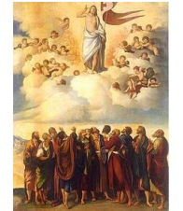  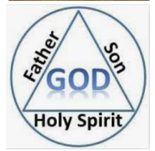
Pentecost | The Christian festival celebrating the Holy Spirit coming on the disciples of Jesus after his Ascension.
Trinity | God the Father, God the Son and God the Holy Spirit.
Holy Spirit | A part of the trinity. The power to help Christians to be like Jesus on Earth.
Key skills
By the end of this unit, pupils are expected to be able to:
- retell the stories of Ascension and Pentecost connecting them with Christian beliefs.
- describe what Christians believe is the impact of the Holy Spirit on people’s lives.
- talk about the ways in which these events help answer questions about God.

