 | RE Year Six  Life as a Journey and Pilgrimage
Key vocabulary | Explanation/ definition | Key Knowledge
Journey | - Act or process of travelling from one place to another.  - Passage or progress from one stage to another. | - Some people undertake a pilgrimage as part of living out their faith.  - The life journey of people in the Bible effects the behaviour, beliefs and life choices of Christians today.  - Being a Christian and following Jesus’ teaching has an impact on a person’s life.  - The life journey of Jesus answers questions about what Christians believe.  - Christians in many countries across the world are persecuted because of their faith.  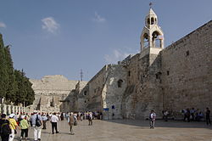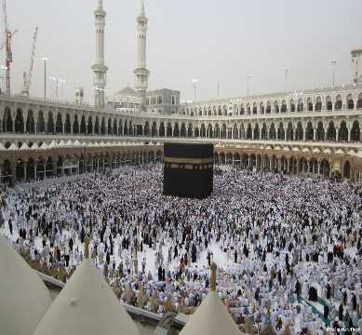  Jerusalem Mecca (Makkah) Saudi Arabia
Pilgrimage | A journey, especially a long one, made to some sacred place as an act of religious devotion.
Rites of passage | A ritual, event, or experience that marks or constitutes a major milestone or change in a person’s life.
Holy Land | A region on the eastern shore of the Mediterranean, in what is now Israel and Palestine, revered by Christians as the place in which Christ lived and taught, by Jews as the land given to the people of Israel, and by Muslims.
Key skills
By the end of this unit, pupils are expected to be able to:
- Recognise similarities and differences between pilgrimages made by Christians and people of other faiths.
- Describe the impact that following the teaching of Jesus has on other people’s lives.
- Describe the features of living life as a Christian.

