 | RE Autumn term 2 Year Five  Christmas. How do our celebrations reflect the true meaning of Christmas?
Key vocabulary | Explanation/ definition | Key Knowledge
Saviour | A person who saves someone or something from danger or difficulty. | - The nativity story is recorded in Gospels of Matthew and Luke.  - The true meaning of Christmas is a celebration of the birth of the Messiah, God in human form, Jesus Christ.  - Different denominations of Christianity hold differing views in the importance of Mary.  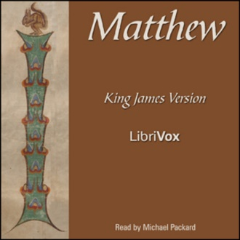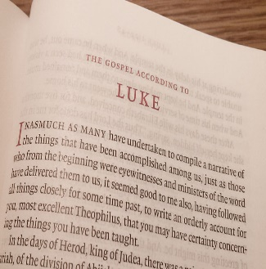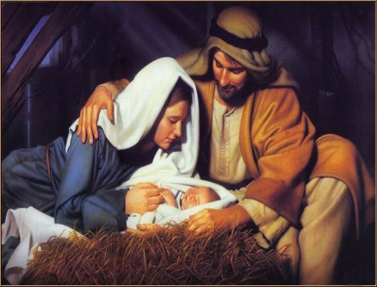
Messiah | The promised deliverer of the Jewish nation prophesised in the Hebrew Bible.  Jesus regarded by Christians as the Messiah of the Hebrew prophecies and the saviour of humankind.
Gospel | A written account of the life and teaching of Jesus Christ.
Mathew | One of Jesus’ apostles (disciples) who is thought to have written the Gospel of Matthew in the New Testament.
Luke | A friend of the apostle (disciple) Paul and believed to have written the Gospel of Luke.
Nativity | The birth of Jesus Christ.
Herod | The king of Judea who (according to the New Testament) tried to kill Jesus by ordering the death of all children under the age of two in Bethlehem.
Incarnation | The Christian belief that Jesus Christ is the God of Israel in a human body.
Salvation | Being saved from certain death.
Key skills
By the end of this unit, pupils are expected to be able to:
- Identify which parts of the story are found in each gospel and the purpose of each writer.
- Identify the influence the two stories have on our Christmas celebrations.
- Describe using religious vocabulary the Christian beliefs revealed in the nativity story.

