 | RE Summer Term 2  Year Four  What is prayer?
Key vocabulary | Explanation/ definition | Key Knowledge
Pray | To speak to God especially to give thanks or ask for something. | - Prayer is the way in which believers communicate with God.  - Prayer is connected to faith.  - Christian beliefs are revealed in the content of prayer.  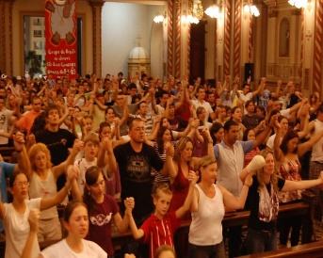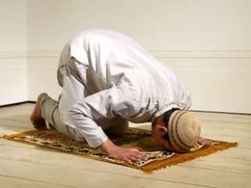  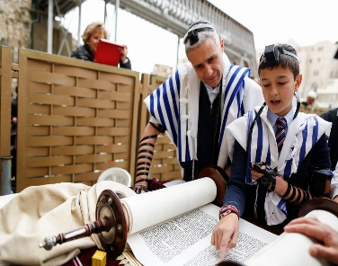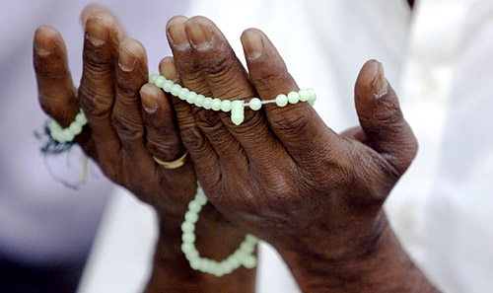
Prayer | A solemn request for help or expression of thanks addressed to God.
Collect | A prayer meant to gather the intentions of the people and the focus of worship into succinct prayer.
Key skills
By the end of this unit, pupils are expected to be able to:
- Talk about similarities and differences in the ways people of faith pray.
- Talk using religious vocabulary to show understanding of the purpose, place and content of prayer in the life of a believer.

