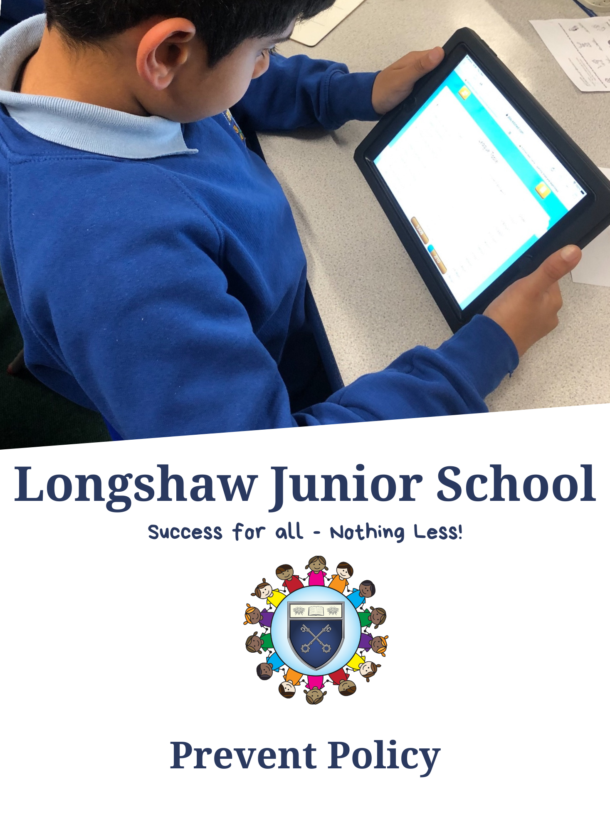

Contents
Revisions 3
Context 3
Aims 3
Definitions 4
Responsibilities and Implications for the school 4
Staff Training 5
Curriculum and Teaching Approaches 6
External Agencies and Speakers 7
Procedures and Referrals 7

Revisions

Policy Written by : Jennifer Taylor and Jonathan Berry

Reviewed: March 2026
Next review date: March 2028

Context
PREVENT is part of the Government’s counter-terrorism strategy. Its aim is to stop people becoming terrorists or supporting terrorism. Prevent addresses all forms of terrorism but continues to prioritise according to the threat they pose to the country’s national security. Prevent involves the identification and referral of those susceptible to violent extremism into appropriate interventions. These interventions aim to divert the susceptible and vulnerable from embarking down the path to radicalisation.

From July 2015 all schools are subject to a duty under section 26 of the Counter-Terrorism and Security Act of 2015, to have ‘due regard to the need to prevent people from being drawn into terrorism’, known as the ‘Prevent Duty’

This advice & guidance will need to be applied within the context of each school’s existing arrangements to safeguard and promote the welfare of all children in line with the statutory duties set out in sections 157 and 175 of the Education Act 2002.

Aims
- teaching staff and governors will have an understanding of what radicalisation and extremism are is and why we need to be vigilant in school.
- teaching staff and governors will know what the school policy is on tackling extremism and radicalisation and will follow the policy guidance swiftly when issues arise.
Teaching staff and governors will understand the dangers of radicalisation and exposure to extremist views; building resilience against these and knowing what to do if they experience them.

Teaching staff and governors will know that the school has policies in place to keep pupils safe from harm and that the school regularly reviews its systems to ensure they are appropriate and effective.

The main aims of this policy are to ensure that staff are fully engaged in being vigilant about radicalisation; that they overcome professional disbelief that such issues will not happen here and ensure that we work alongside other professional bodies and agencies to ensure that our pupils are safe from harm.

Definitions
The following definitions create clarity when discussing radicalisation and extremism:
Ideology – a set of beliefs.
Extremism – a vocal or active opposition to fundamental British values, including democracy, the rule of law, individual liberty and mutual respect and tolerance of different faiths and beliefs.
Radicalisation – the process by which a person comes to support terrorism and forms of extremism leading to terrorism.
Terrorism – an action that endangers or causes serious violence damage or disruption and is intended to influence the Government or to intimidate the public and is made with the intention of advancing a political, religious or ideological cause.

When applying this guidance we use the following accepted Government definition of extremism, which is:

‘Vocal or active opposition to fundamental British values, including democracy, the rule of law, individual liberty and mutual respect and tolerance of different faiths and beliefs; and/or calls for the death of members of our armed forces, whether in this country or overseas’.

Responsibilities and Implications for the school
There is no place for extremist views of any kind at Longshaw Junior School, whether from internal sources – pupils, staff, governors or external sources – school community, external agencies or individuals. Pupils need to see Longshaw Junior School as a safe place where they can explore controversial issues openly and where teachers encourage and facilitate this. We have a duty to ensure this happens.

Longshaw Junior School will recognise that extremism and exposure to extremist materials and influences can lead to poor outcomes for children and so these issues must be addressed as a safeguarding concern.

It is recognised that if we fail to challenge extremist views, we are failing to protect our pupils. Extremists of all persuasions aim to develop destructive relationships between different communities by promoting division, fear and mistrust of others based on ignorance or prejudice and thereby limiting the life chances of young people. Education is a powerful tool to challenge this; equipping young people with the knowledge, skills and critical thinking, to challenge and debate in an informed way.

Longshaw Junior School will provide a broad and balanced curriculum, delivered by skilled professionals, so that pupils are enriched, valued, tolerant of difference, understand diversity, and do not feel marginalised.

We are aware that young people may be exposed to extremist influences or prejudiced views from an early age, which can emanate from a variety of sources, including the media and internet. At times pupils may themselves reflect or display views that can be discriminatory, prejudiced or extremist, including using derogatory

language. Any prejudice, discrimination or extremist views displayed by pupils or staff will need to be challenged and where appropriate dealt with in-line with school policies such as the Behaviour Policy or the Staff Code of Conduct.

As part of safeguarding responsibilities, school staff are alert to:

Pupils disclosing their exposure to extremist actions, materials or the views of others outside of school, such as in their homes or community groups, especially where pupils have not actively sought these out;

Graffiti symbols, writing or art work promoting extremist messages or images;

Pupils accessing extremist material online, including through social networking sites

Parental reports of changes in behaviour, friendships or actions and requests for assistance;

Partner schools, local authority services, and police reports of issues affecting pupils in other schools or settings;

Pupils voicing opinions drawn from extremist ideologies and narratives;

Use of extremist or ‘hate’ terms to exclude others or incite violence;

Intolerance of difference, whether secular or religious or (in line with our equalities policy) views based on, but not exclusive to, gender, disability, homophobia, race, colour or culture;

Attempts to impose extremist views or practices on others;

Anti-British views.

At Longshaw Junior School we follow any locally agreed procedure as set out by the Local Safeguarding Children Board, including criteria for safeguarding individuals vulnerable to extremism and radicalisation. In the event of concerns about a person at risk of becoming radicalised, contact will be made with Lancashire Constabulary’s Prevent Team to consider whether it is appropriate to refer the individuals to the Channel process.

Channel is a bespoke multi-agency approach, which uses early intervention to protect and divert people away from the risks they face. Referrals can be made by anyone who has concerns. The Channel Panel is chaired by the local authority and meets at regular intervals to discuss referrals on individuals who have been identified as being at risk of radicalisation but have not committed any terrorism offence. For further details visit: https://www.gov.uk/government/publications/channel-guidance

Staff Training
Through INSET and Staff Meeting opportunities in school, we will ensure that our staff are fully aware of the threats, risks and vulnerabilities that are linked to radicalisation; are aware of the process of radicalisation and

how this might be identified early on and are aware of how we can provide support as a school to ensure that our children are resilient and able to resist involvement in radical or extreme activities.

Training is delivered through online learning platforms and through Local Authority officers. Records of training are kept as part of our safeguarding procedures.

The designated safeguarding lead attend safeguarding update training every two years with updates passed on to staff.

All staff receive safeguarding training annually which will include training on extremism and radicalisation

Curriculum and Teaching Approaches
All staff at Longshaw Junior School strive to eradicate the myths and assumptions that can lead to some young people becoming alienated and disempowered, especially in situations where children may find it harder to challenge or question radical influences. This will be achieved by good teaching, including PSHE.

These teaching approaches will help pupils build resilience to extremism and give them a positive sense of identity through the development of critical thinking skills. It is important to ensure that all staff are equipped to recognise extremism and are skilled and confident enough to challenge it.

We are flexible enough to adapt our teaching approaches, as appropriate, to address specific issues, enabling them to become more relevant to current issues of extremism and radicalisation.

Our school aims to:

- Make a connection with children & young people through good teaching and a pupil centred approach;

- Facilitate a ‘safe space’ for dialogue; and

- Empower pupils with the appropriate skills, knowledge, understanding and awareness for resilience.

This approach will need to be embedded within the school ethos, so that pupils know and understand what safe and acceptable behaviour is within the context of extremism and radicalisation. This will work in conjunction with each school’s approach to the spiritual, moral, social and cultural development of pupils.

Longshaw Junior School also work with local partners, families and communities in their efforts to ensure better understanding and embrace the local context and values in challenging extremist views and to assist in the broadening of their pupil’s experiences and horizons.

We will need to support pupils who may be vulnerable to such influences as part of their wider safeguarding responsibilities. Where staff believe extremist materials or influences are directly affecting a pupil, they will need to ensure that that pupil is offered mentoring. Additionally, the school should seek external support from the Local Authority Prevent Coordinator and the Education Safeguarding Officer. (See contact Details Below)
Longshaw Junior School promotes the values of democracy, the rule of law, individual liberty, mutual respect and tolerance for those with different faiths and beliefs by teaching and encouraging pupils to respect one another and to respect and tolerate difference, especially those of a different faith or no faith. It is our responsibility to keep pupils safe and prepare them for life in modern multi-cultural Britain.

External Agencies and Speakers
We encourage the use of external agencies or speakers to enrich the experiences of their pupils. However, we vet these individuals and any organisations which provide such learning opportunities or experiences for pupils. The vetting processes ensures that we do not unwittingly use agencies or individuals that contradict each other with their messages or that are inconsistent with, or in opposition to, the school’s values and ethos and to ensure that this is of benefit to all pupils.

Longhsaw Junior School will therefore assess the suitability and effectiveness of input from external agencies or individuals to ensure that:
- Any messages communicated to pupils are consistent with the ethos of the school and do not marginalise any communities, groups or individuals;
- Any messages do not seek to glorify criminal activity or violent extremism, or seek to radicalise pupils through extreme or narrow views of faith, religion, culture or other ideologies;
- Activities are matched to the needs of pupils;

- Speakers are evaluated by the school to ensure they are effective.

Procedures and Referrals

It is important for us to be constantly vigilant and remain fully informed about the issues which affect the local area and society in which we teach. Staff are reminded to suspend any ‘professional disbelief’ that instances of radicalisation ‘could not happen here’ and to be ‘professionally inquisitive’ where concerns arise, referring any concerns through the appropriate channels.

We believe that it is possible to intervene to protect people who are vulnerable. Early intervention is vital and staff must be aware of the established processes for front line professionals to refer concerns about individuals

and/or groups. We must have the confidence to challenge, the confidence to intervene and ensure that we have strong safeguarding practices based on the most up-to-date guidance and best practice.

Designated Safeguarding Leads (DSL) for Child Protection and Safeguarding will deal swiftly with any referrals made by staff or with concerns reported by staff.

We are aware of the potential indicating factors that a child is vulnerable to being radicalised or exposed to extreme views, including peer pressure, influence from other people or the internet, bullying, crime and anti- social behaviour, family tensions, race/hate crime, lack of self-esteem or identity, prejudicial behaviour and personal or political grievances

In the event of prejudicial behaviour the following system will be followed;

All incidents of prejudicial behaviour will be reported directly to the Designated Safeguarding Lead and added to CPOMS under the category PREVENT

All incidents will be fully investigated and records will be kept in line with procedures for any other safeguarding incident. Parents and carers will be contacted and the incident discussed, aiming to identify motivating factors, any changes in circumstances at home, parental views of the incident and to assess whether the incident is serious enough to warrant a further referral. A note of this meeting is kept alongside the initial record on CPOMS

The Head Teacher and Senior Leadership Team will discuss the most appropriate course of action on a case-by- case basis and will decide when a referral to external agencies is needed

The DSL will monitor any incident for a period of four weeks after the incident to assess whether there is a change in behaviour and/or attitude. A further meeting with parents would be held if there is not a significant positive change in behaviour.

The DSL will make contact with the prevent Team to discuss next steps (If required)

Leanne Romney Prevent Education Officer Lancashire Leanne.romney@blackburn.gov.uk prevent.team@blackburn.gov.uk
Blackburn with Darwen Prevent Team 01254 585260

In the event of a referral relating to serious concerns about potential radicalisation or extremism, the school will also contact Lancashire Police

concern@lancashire.pnn.police.uk

Lancashire Police Prevent Officers can be contacted by: telephone: 01282 472329/ 01282 472324

Or

The police non-emergency number 101 Anti-terrorism hotline 0800 789 321
More information can be found on the Lancashire Constabulary website

IF THERE IS AN IMMEDIATE RISK 999 WILL BE CALLED IMMEDIATELY

Alternatively contact the police confidentially on the Anti-terrorist hotline 0800 789 321.

